**CUSTOMIZED SES PRODUCT MONITORING**

**SYSTEM**

**A PROJECT REPORT**

***SUBMITTED BY***

**THAMODHARAN G - 810020106088**

**BALAJI M - 810020106302**

**AKASH K - 810020106306**

***in partial fulfillment for the award of the degree***

***of***

**BACHELOR OF ENGINEERING**

***In***

**ELECTRONICS AND COMMUNICATION ENGINEERING**

**UNIVERSITY COLLEGE OF ENGINEERING (BIT CAMPUS)**

**ANNA UNIVERSITY: CHENNAI - 600 025**

**MAY 2024**

**CUSTOMIZED SES PRODUCT MONITORING SYSTEM**

**A PROJECT REPORT**

***SUBMITTED BY***

**THAMODHARAN G - 810020106088**

**BALAJI M - 810020106302**

**AKASH K - 810020106306**

***in partial fulfillment for the award of the degree***

***of***

**BACHELOR OF ENGINEERING**

***In***

**ELECTRONICS AND COMMUNICATION ENGINEERING**

**UNIVERSITY COLLEGE OF ENGINEERING (BIT CAMPUS)**

**ANNA UNIVERSITY: CHENNAI - 600 025**

**MAY 2024**

**BONAFIDE CERTIFICATE**

Certified that this project report **“CUSTOMIZED SES FOR PRODUCT MONITORING SYSTEM USING AIOT”** is a bonafide work of **“ Thamodharan G (810020106088) ,Balaji M (810020106302),Akash K (810020106306) ,”** who is carried out the project work under my supervision.

**SIGNATURE SIGNATURE**

**Dr.P.RAMADEVI, Dr.M.BHUVANESWARI**

**Associate Professor, Assistant Professor (sr.Gr),**

**HEAD OF THE DEPARTMENT** Department of Electronics and

Department of Electronics and Communication Engineering,

Communication Engineering, University College of

University College of Engineering, Engineering, BIT Campus,

BIT Campus, Tiruchirappalli -620024.

Tiruchirappalli -620024.

Submitted for “EC8811 - Project work” in B.E of Electronics and Communication Engineering Jan - May 2024 Examination held on …../…../………

**Internal Examiner External Examiner**

**ANNA UNIVERSITY,**

**BIT CAMPUS, TRICHIRAPPALLI,**

**DEPARTMENT OF ELECTRONICS AND COMMUNICATION ENGINEERING**

**ENGINEERING**

### Vision:

To enable the student blossom as competent professional with cutting edge Electronics and Communication technologies for the fulfilment of Industrial and societal needs.

### Mission:

1. To achieve competency by importing necessary attitude, knowledge and skill sets in the field of Electronics and Communication Engineering.
2. To reinforce professional skills in cutting edge technologies through hands on training.
3. To accomplish excellence in academics by appropriate practices/training.
4. To ensure and emphasize the attainability of societal needs by developing creative Electronics and communication Engineering prototypes.

**PROGRAMME SPECIFIC OUTCOMES**

The graduates, on successful completion of the Bachelor degree in Electronics and Communication Engineering will be able to

**PS01:** Ability to apply the acquired knowledge of basic skills, mathematical foundations, principles of electronics, modeling and design of electronics-based systems in solving

engineering Problems.

**PS02:** Ability to understand and analyze the interdisciplinary problems for developing innovative sustained solutions with environmental concerns.

**PS03:** Ability to update knowledge continuously in the tools like MATLAB EMBESTIDE, XILINX and technologies like VLSI, Embedded, Wireless Communication to meet the industry requirements.

**PS04:** Ability to manage effectively as part of a team with professional behaviour and ethics.

**DECLARATION**

We hereby declare that the work entitled **" CUSTOMIZED SES FOR PRODUCT MONITORING SYSTEM USING AIOT** " submitted in partial fulfillment of the requirement for the award of the degree in B.E.,University College of Engineering, BIT Campus, Anna University, Trichirappalli is a record of my work carried out by me during the academic year 2023-2024 under the supervision of **Dr.M.BHUVANESWARI**. Assistant Professor (Sr.Gr). Department of Electronics and Communication Engineering, University College of Engineering, Anna University, BIT Campus, Tiruchirappalli. The extent and source of information are derived from the existing literature and have been indicated through the dissertation at the appropriate places.

The matter embodied in this work is original and has not been submitted for the award of any other degree or diploma, either in this or any other university**.**

**(Signature of the Candidate) (Signature of the Candidate)**

**THAMODHARAN G BALAJI M**

**(Signature of the Candidate)**

**AKASH K**

I certifythat the declaration made by the above candidate is true.

**(Signature of the Guide)**

**Dr.M.BHUVANESWARI**

**Assistant Professor (Sr.Gr.**

Department of Electronics and Communication Engineering ,

University College of engineering,BIT Campus,Trichy.

**ACKNOWLEDGEMENT**

All praise, glory and honour to the Lord Almighty, for his gracious presence and guidance that enable us to complete this project duly.

We wish to express our profound thanks to **Dr T. SENTHILKUMAR**, Dean, University College of Engineering, BIT Campus, Tiruchirappalli, for granting us permission for doing this project work.

We wish to express our sincere thanks to **Dr P. RAMADEVI**, Head of the Department of Electronics and Communication Engineering, University College of Engineering, BIT Campus, Tiruchirappalli, for her support and ardent guidance.

We owe our special thanks and gratitude to **Dr M.BHUVANESWARI**, Teaching fellow, Department of ECE, University College of Engineering, BIT Campus, Anna University, Tiruchirappalli, who guided us throughout our project with his timely help, guidance with valuable suggestions.

We express our heartfelt thanks to our project review committee members, Department of Electronics and Communication Engineering for their passionate support, for helping us to identify our mistakes and also for the appreciation they gave us in achieving our goals. We heartily thank

our lab assistants and management for their support by way of providing the information and resources that helped us to complete the project successfully. Also, we would like to record our deepest gratitude to our parents and friends for their constant encouragement and support which motivated us to complete our project on time.

**CUSTOMIZED SES FOR PRODUCT MONITORING USING AIOT**

**Abstract**

At present, the process of manual product monitoring system is facing problems of delay reports ,data missing and mismatch. So, to address this deficit, an automated SES-Subordinate Electronic System comprising of RFid with AIoT is proposed. RFid technique is used for approved credentials of the products followed by advanced facial recognition using AIoT to counter unauthorized access. The outcome of this proposal will address the qualitative measures such as accuracy, efficiency, reducing instances and quantitve measures such as 95% accuracy rate, measured through comparative analysis of manual and automated records. The integration of RFid and face recognition technologies offers a comprehensive solution for more reliable, secure and information retrieval/storage for SES product monitoring system. Thus, this customized SES is applicable for educational institutions, library administrations, hospitals and corporate offices.

**ABSTRACT IN TAMIL**

தொழில் உற்பத்தியை கண்காணிக்கும் அமைப்பின் நிலையில், தாமதம் அறிக்கைகள், தரவு காணப்படாதது மற்றும் பொருள் மீட்பு சொல்லுதல் பிரச்சினைகளுடன் எதிர்க்கின்றன. அந்த இழுக்கத்தை சரிசெய்து, ஒரு தானியங்கி SES-தனியங்கி எலெக்ட்ரானிக் அமைப்பு அமைக்கப்படுகின்றது. RFid முறையை உபயோகித்து பொருள்களின் அங்கீகரிக்கப்பட்ட உறுதிப்பாடுகள் அரசுக்கு அடிப்படையில், பின்னர் அதிக பதிவு செய்தல் மூலம் பல்வேறு அணுகுமுறைகளை எதிர்கொள்ள அதிகமான முயற்சியை உருவாக்குகின்றது. பதிவுசெய்யப்படும் இயல்பு, சரியான, செல்வம் குறைக்கும் நேரங்கள் மற்றும் கணினி நம்பிக்கை அளிக்கும் வகையில் உயர்த்துகின்றது. மென்பொருள் மற்றும் முன்மொழிபெயர்ப்புகளின் ஒருங்கிணைப்பு, குறித்து பெரும்பாலும் நிர்வாகமான தீர்வுகள் மற்றும் தகவல் எடுத்துக்கொள்ளல்/சேமிக்கலாம். அதாவது, இந்த விருப்பமான SES கல்வி நிறுவனங்களுக்கு, நூலக நிர்வாகங்களுக்கு, மருத்துவமனைகளுக்கு மற்றும் கார்ப்பரேட் அலுவலகங்களுக்கு பொதுவான பயன்படுத்தப்படும்.

**TABLE OF CONTENT**

|  |  |  |
| --- | --- | --- |
| **CHAPTER NO** | **TITLE** | **PAGE NO** |
|  | **ACKNOWLEDGEMENT**  **ABSTRACT**  **LIST OF FIGURE**  **LIST OF ABBREVIATIONS** |  |
| **1** | **INTRODUCTION** |  |
| **2** | **LITERATURE SURVEY** |  |
| **3** | **SYSTEMANALYSIS**  3.1 Problem Statement  3.2 Existing system  3.2.1 Disadvantages  3.3 Proposed System  3.3.1 System Architecture   * + 1. Advantages |  |
| **4** | **SYSTEM SPECIFICATION**  4.1Hardware Requirements  4.2Software Requirements06-05-2024  4.3Software Description |  |
| **5** | **UML DIAGRAMS** |  |
| **6** | **SYSTEM IMPLEMENTATION** |  |
| **7** | **RESULT AND DISCUSSION** |  |
| **8** | **CONLCUSION AND FUTURE ENHAMCEMENT**  **APPANDIX**  **REFERENCES** |  |

**CHAPTER 1**

**INTRODUCTION**

**1.1 Overview**

Attendance Management keeps track of your employee or students present/absent details. It is the system to document the time your employees/students work and the time they take off. In this digital era, face recognition system plays a vital role in almost every sector. Face recognition is one of the mostly used biometrics. It can used for security, authentication, identification. This is an artificial intelligence based attendance management system with face recognition technology. The main objective of this AI based software solution is to update attendance with employees' face using computer vision.

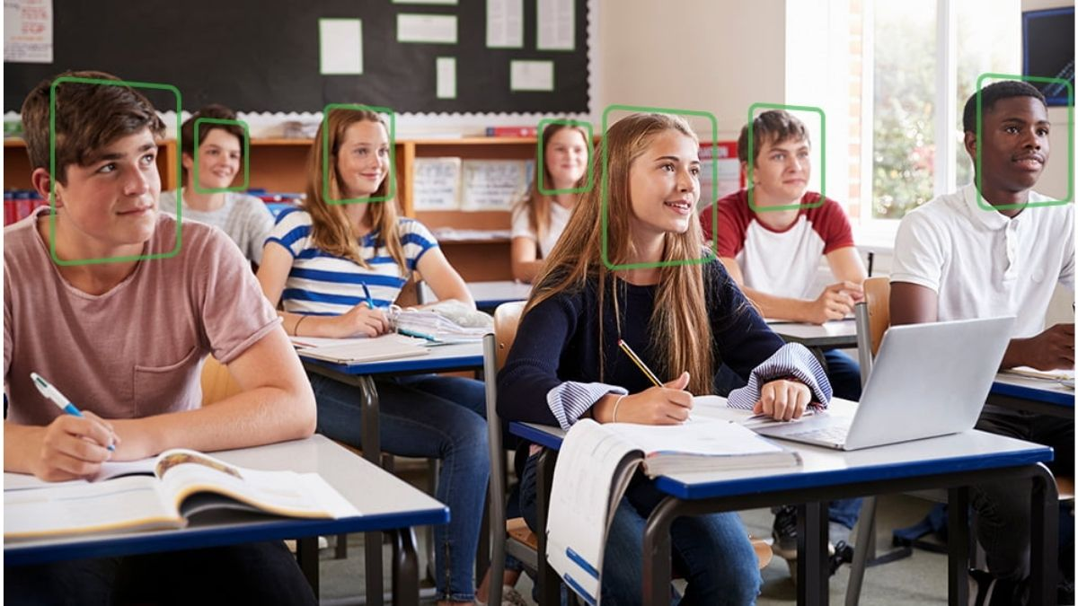

Fig. 1.1 Face recognization

In order to realize a highly efficient and robust attendance management system for virtual learning, we introduce the Random Interval Attendance Management System (RIAMS), is a Web Application developed using Deep Learning. It is implemented using Deep Convolutional Neural Networks(DCNN) Algorithm The significance of the RIAMS model is that it precisely monitor attendance in virtual classrooms without hindering the learning process. Further, it can generate dedicated attendance reports, pinpointing students’ attention during virtual learning at random time intervals. Randomness ensures that students cannot predict at which instant of time the attendance is registered. Another added advantage of the RIAMS approach is that it requires only nominal internet bandwidth in comparison with the existingface recognition based attendance tracking systems. Existingface recognition systems require student’s video cameras to be kept ‘ON’ throughout the virtual classroom session. The proposed model can be easily scaled and integratedinto a wide variety of virtual meetings, including business meetings. Educational institutes applying the RIAMS system can effectively monitor the attendance without affecting the learning objectives ofthe class. Similar to other Virtual classroom it contains existing features. RIAMS virtual classroom includes the following additional features:

**1.5.Problem Identified**

Identifying problems in attendance management systems is crucial for ensuring accurate and efficient tracking of employee attendance. Several common issues can arise within these systems, impacting organizational productivity and employee satisfaction. One prevalent problem is inaccurate data recording, often resulting from manual entry errors or outdated tracking methods. Inefficient manual processes such as paper-based attendance sheets or manual data entry into spreadsheets can lead to discrepancies, inaccuracies, and time-consuming corrections. These inaccuracies can compromise the reliability of attendance records and hinder decision-making processes such as payroll calculations and performance evaluations.

Another issue is the lack of real-time tracking and monitoring capabilities in traditional attendance management systems. Without real-time visibility into employee attendance, supervisors may struggle to identify absenteeism patterns, address attendance issues promptly, or allocate resources effectively. This can result in productivity losses, missed deadlines, and challenges in workforce planning and scheduling.

**1.6 Deep Learning**

Deep learning using face detection is a cutting-edge technology that revolutionizes various applications, from security systems to social media platforms. Leveraging advanced neural network architectures, such as Convolutional Neural Networks (CNNs), this approach enables highly accurate and efficient detection of human faces within images or video streams. At the heart of deep learning-based face detection lies the ability to automatically learn and extract intricate features from raw image data, allowing the model to discern facial characteristics despite variations in lighting conditions, poses, and occlusions. Through iterative training on vast datasets containing annotated face images, deep learning models can generalize well to detect faces in diverse real-world scenarios. The deployment of deep learning-based face detection systems facilitates a wide range of applications, including facial recognition for identity verification, emotion detection for human-computer interaction, and facial analysis for demographic profiling.

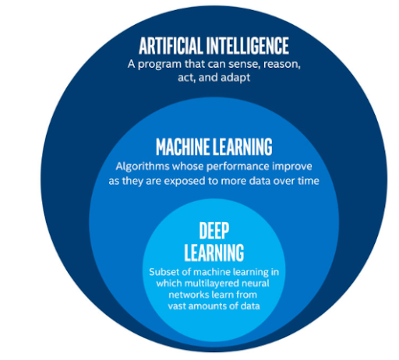

Fig. 1.2 Deployment of Languages

Additionally, the advent of deep learning frameworks and hardware accelerators has significantly accelerated the deployment of real-time face detection systems, making them accessible for various industries and use cases. However, challenges such as privacy concerns, bias in training data, and computational resource requirements warrant careful consideration in the development and deployment of deep learning-based face detection solutions. Overall, deep learning-based face detection represents a powerful and versatile tool that continues to drive innovation across numerous domains, offering unprecedented capabilities for understanding and interacting with human faces in the digital world.

**1.7. Scope of the Project**

* The primary objective of the project is to implement RFID and face recognition technology to automate the process of product attendance tracking.
* This involves integrating RFID readers and facial recognition cameras into existing infrastructure to facilitate seamless attendance recording.
* The system will eliminate the need for manual attendance taking, thereby reducing administrative workload and minimizing errors associated with manual data entry.
* By automating the attendance tracking process, the project aims to significantly reduce the administrative workload involved in manual attendance management.
* Administrative staff will be relieved from the repetitive task of recording attendance manually, allowing them to focus on more strategic and value-added activities.
* The project will involve integrating the RFID and face recognition attendance tracking system with existing campus infrastructure and information systems.
* This integration ensures seamless data synchronization and compatibility with other administrative processes, such as student records and payroll management.

**1.8 Objective**

* Implementing RFID and face recognition technology to automate the process of product attendance tracking. This eliminates the need for manual attendance taking, reducing administrative workload and minimizing errors.
* Utilizing face recognition technology adds an extra layer of security to the product attendance based SES system, ensuring that only authorized individuals can mark their attendance. This SES helps prevent instances of proxy attendance and enhances overall campus security.

**CHAPTER 2**

**LITERATURE SURVEY**

# 2.1 Title:

# A Face Recognition-Based Smart Student Attendance and Activeness Monitoring System

# Authors: Atharva Ghodekar

**Description**

A Face Recognition-Based Smart Student Attendance and Activeness Monitoring System represents a transformative solution to revolutionize attendance management within educational institutions. This project introduces a new way of tracking student attendance in schools, moving away from traditional methods like calling names or using cards. We're using advanced facial recognition technology, specifically the OpenFace model, to make attendance more accurate and easier. This system corrects mistakes intelligently and refines its data for better performance. A distinctive feature of the system involves the incorporation of the Haar Cascade model to monitor student engagement. Which does more than just track attendance. It watches students' facial expressions and head movements in real-time. This gives teachers insights into how engaged students are in class, helping them improve participation. Teachers get immediate feedback, allowing them to adjust their teaching methods for a more interactive and enjoyable learning experience. Our system doesn't just focus on attendance, it takes a broader approach by monitoring student engagement. By simplifying tasks for school staff and giving helpful information, this system has the potential to change how schools operate. It uses cutting-edge technology to make attendance and engagement monitoring easy, promising to create better classroom experiences for everyone involved.

# 2.2 Title:

# Effortless Attendance Management:

# Unleashing Advanced Face Detection and Recognition in an Automated System

# Authors: Monali Gulhane; Vedant Shrirao

**Description**

In the digital world, precise attendance tracking has grown more urgent because of the COVID-19 concerns facing the world, which raised the need for an automatic attendance system in various areas without any human physical contact. Our research addresses this need by creating a contactless attendance tracking and monitoring solution with accurate results that is automated and uses robust face detection and identification technology. The proposed work explores the assessment of a computerized approach that uses cutting-edge face recognition and recognition approaches in light of the rising demand for effective and precise attendance tracking systems. The proposed work meticulously analyzes the system's performance on a real- time self-dataset. The results show a consistent connection between distance and confidence level regarding face detection, which is visually demonstrated in our data. In particular, our results show higher confidence levels than other state-of-art algorithms. We suggest setting a confidence level for attendance marking based on these revelations. Our proposed work suggests potential directions for future improvements, such as system expansion to handle larger student populations with the fusion of machine learning algorithms.

# 2.3 Title: An Efficient Face Recognition Based Attendance System

# Authors: Nancy Deborah R

**Description**

The maintenance of attendance can be notable issue for teachers, if it's far accomplished by using hand. To solve these types of issues, Automatic attendance management system is put forward. Through employing this approach, the problems related to attendance, such as the college students being recorded present even though they are absent, can be effortlessly be solved. This machine marks the attendance the usage of live video circulation with the aid of a surveillance camera. We've proposed a novel algorithm known as spectra sense at the side of haar cascasde to implement this. The principle procedural stages used in this kind of machine are face detection and recognizing the detected face, for that purpose dlib is being used. After those, the identified faces must be manageable by way of cross-referencing with the database comprising pupil's faces. This system has potential to be an effective method of handling the attendance of college students. In contrast to other sorts of biometric era, inclusive of fingerprint recognition, which captures identification through touching, it also manages employees without the technique of direct touch. Face recognition captures the field employee's attendance marking time.

# 2.4 Title: A Novel QR Code Based Smart Attendance Tracking System

# Authors: Soham Pati; Souvik Bhanja

# Description

This work proposes a novel attendance tracking system based on QR code. The implementation of a QR-based attendance system in educational institutions represents a technological advancement which ensures the accuracy of attendance tracking. The process begins with students registering with the institutional organization. Following registration, each student is assigned a unique QR code, which is subsequently printed on their institutional ID card. This QR code serves as a personalized identifier for attendance tracking purposes. The operational procedure involves students scanning their QR codes using installed cameras upon entering and leaving the college premises. The system captures this data and calculates attendance percentages automatically. The recorded information includes not only the attendance status but also the precise entry and exit timestamps. This comprehensive dataset is then stored in the student database, organized according to the academic calendar. The utilization of QR codes in this context simplifies the overall system operation, reducing the chances of errors in attendance tracking. The implementation of technology into the attendance recording process enhances efficiency and minimizes the load on administrative staff.

# 2.5 Title:

# Student Attendance Management System Based on Fingerprint Identification Technology

# Authors: Yi Yi

**Description**

Accurate and efficient management of student attendance is a prerequisite for ensuring the healthy development of students and cultivating high-quality talents, and is also a top priority in school work. The establishment of attendance management system can solve the problems of delays and low efficiency in human resource management and attendance rate statistics in the past. The aim of this paper is to study the design and implementation of a student attendance management system based on fingerprint recognition technology. The design requirements and principles of the fingerprint recognition assisted management system are analysed, the overall structure of the system is designed, the functions and applications of fingerprint recognition technology are reasonably designed and adopted, and finally the fingerprint recognition assisted management system is implemented. The results show that after the system is implemented, it makes attendance more convenient, fast and standardized compared with the traditional methods of punching cards and signing on behalf of students, which greatly improves the learning efficiency of students in universities.

# 2.6 Title:

# Smart Attendance Registration and Management System through AI

# Authors: G Rajesh; N Sairam

**Description**

Automatic Facial Recognition (AFR) stands as a widely employed technology in today’s rapidly advancing world. Within the context of a smart attendance system, real-time facial recognition is employed to track student attendance by capturing and processing their facial features in real-time, comparing them to a stored database. This facial recognition process swiftly identifies and verifies students, providing precise results when analyzing video inputs. There are several existing frameworks for facial recognition, and to enhance both the speed and accuracy of recognition, a new framework is proposed. This novel approach leverages deep learning techniques for video processing, modifying the existing Convolutional Neural Network (CNN) architecture to incorporate specialized features into a versatile neural network design. The proposed model considers artificial intelligence enabled Split Invariant Artificial Neural Network (SIANN) to make efficient attendance registration and management system. The proposed model performance is measured through accuracy, loss function etc.

# 2.7 Title:

# Utilizing QR Codes for Smart and Low-cost Student Attendance Acquisition and Monitoring System in Eastern Visayas State University, Philippines

# Authors: John Dominique Ebin

**Description**

SDG 4 that pertains to quality education can be initialize through schools and universities for direct impact. Thus, one way to have quality education is to ensure that students go to school and receive learning from the academe. However, absenteeism has a significant impact on their academic achievement of every student since those who attend school consistently are more likely to thrive academically. With that, this study aims to address absenteeism using a smart attendance acquisition and monitoring system. The first objective is to design and build a prototype of the Student Attendance Acquisition System (SAAS) utilizing QR code technology and the Raspberry Pi. Then, the establishment of web server for the Attendance Monitoring System (AMS) that can store, retrieve, and display attendance data can be employed. Finally, the constructed system's efficiency must be able to test for reliability and identify the top absentees among the participants. Thus, using the QR code technology, there were no problem in the system after testing to 10 BSECE students over five consecutive days. The prototype is highly efficient and has a strong potential for EVSU attendance system improvement, which might reduce absenteeism and increase student performance in the BSECE department and to the university.

# 2.8 Title:

# A New Way of Recording Attendance of the Students using Face Recognition System

# Authors: Poonam Gupta

**Description**

People’s connections at work affect the environment there, which is a crucial aspect of everyday supervision. However, keeping track of people’s present and absences may be done via attendance. For many years, techniques that need paper have been used to record attendance of the students. This engagement strategy had been around for a while. For a small number of participants, this approach could be suitable and workable, but it would take a lot of time and effort for a larger group. This approach has well-known and quite well disadvantages, including time requirements, an error-prone nature, and the potential for proxy participation. Using facial recognition software, we provide a useful and stylish solution to track attendance. In order to ascertain if a person is there, the technology will recognize their face and comparing it to the database. Additionally, the vital information is retained with school records and time, and if required, manual changes may be made. This method may be used to address the issue of intermediaries and false attendees.

# 2.9 Title:

# Smart Attendance Management System Using Encrypted QR Codes and Load Balancing

# Authors: [Gokul Ramanan](https://ieeexplore.ieee.org/author/37089724050)

**Description**

Over the recent years, lots of efforts have been undertaken to improve the existing monotonous and time consuming task of recording attendance in a classroom which includes systems such as biometric scanners and RFID devices. Taking into account various factors such as cost, ease of use and scalability, an encrypted QR code based attendance system has been proposed in this paper based on the students location to prevent proxy. The system will send every student within the boundaries of the classroom a unique QR Code in order to mark their attendance. Digital attendance reports and regular data backups help in enhancing the efficiency and reliability of the system. Considering the large number of requests coming through in an educational institution, a multi-server architecture with load balancing to distribute the heavy traffic has been proposed. A comparative study of four load balancing algorithms like round robin, ip hash, least connection and weighted round robin was analysed based on their performance on the system.

# 2.10 Title: Deep Learning based Facial Recognition System for Attendance Maintenance

# Authors: K. G. Saravanan

**Description**

For attendance purposes, face recognition technology can be used to identify individuals within a company. In order to assess the effectiveness of any organisation, attendance records must be maintained and evaluated. Automating the conventional method of recording attendance is the aim of building an attendance monitoring system. The Yale face database has 95.76 percent of the Automated pictures. The Haar-cascade classifier and the LBPH (Local Binary Pattern Histogram) algorithm, both of which are implemented in Python and the OpenCV library, are used in our proposed model to identify the positive and negative features of the face. Numerous algorithms and techniques have been developed to enhance face recognition performance. The Tkinter GUI interface is utilised for user interface purposes. The everyday tasks of attendance marking and evaluation are handled by the attendance management system with less human interaction. For attendance purposes, face recognition technology can be used to identify individuals within a company. In order to assess the effectiveness of any organisation, attendance records must be maintained and evaluated. Automating the conventional method of recording attendance is the aim of building an attendance monitoring system. The everyday tasks of attendance marking and evaluation are handled with less human interaction thanks to the Automated Attendance Management System. The best outcomes from the algorithm, enhanced LBP, and PCA are then used to classify and recognise the facial images. The attendance of the identified student will then be noted and saved in an excel file. Students who sign in more than once will be alerted, and those who are not registered will be able to do so right away. When trained on two images per person, the average recognition accuracy for high-quality images is 100%, for low-quality images it is 94.11%, and for the Yale face database it is 95.76%. The Haar-cascade classifier and the LBPH (Local Binary Patterns).

**CHAPTER 3**

**SYSTEM ANALYSIS**

**3.1 Existing System**

* **Barcode Scanning**

Another method involves issuing students unique barcode identifiers that they scan upon entry to record their attendance. Similar to RFID systems, barcode scanning automates the attendance-taking process and reduces reliance on manual data entry. However, it requires students to have access to barcode scanners or mobile devices equipped with barcode scanning capabilities, which may not be universally available or practical in all educational settings.

* **Biometric Attendance Systems**

Biometric attendance systems utilize students' unique biological traits, such as fingerprints, facial features, or iris patterns, to verify their identity and record attendance. These systems offer high accuracy and security, as each student's biometric data serves as their unique identifier. However, implementing biometric systems can be costly and may raise privacy concerns among students and parents.

**3.2.1 Disadvantages**

* Limited Scalabilit
* Lost or Damaged Cards
* Equipment Dependency
* Costly Implementation

**3.3 Proposed System**

* **RFID**

RFID technology involves the use of electromagnetic fields to automatically identify and track tags attached to objects or individuals. In the context of a student attendance system, each student is provided with an RFID tag, typically embedded within an ID card or wearable device. RFID readers installed at entry points to classrooms or the educational institution detect these tags as students enter or exit.

* **Face Recognition**

Face recognition technology utilizes biometric principles to identify and verify individuals based on their facial features. In a student attendance system employing face recognition, cameras are installed at entry points or within classrooms to capture images of students' faces as they enter.

**DCNN**

CNNs are a category of Neural Networks that have proven very effective in areas such as Image recognition and classification. CNNs are a type of feed-forward neural networks made up of many layers. CNNs consist of filters, kernels, or neurons that have learnable weights or parameters and biases. Each filter takes some inputs, performs convolution and optionally follows it with a non-linearity.

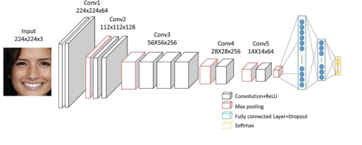

Fig. 3.1 DCNN

**Convolutional Layer**

Convolutional layer performs the core building block of a Convolutional Network that does most of the computational heavy lifting. The primary purpose of Convolution layer is to extract features from the input data which is an image. Convolution preserves the spatial relationship between pixels by learning image features using small squares of input image. The input image is convoluted by employing a set of learnable neurons. This produces a feature map or activation map in the output image and after that the feature maps are fed as input data to the next convolutional layer.

**3.2.1 Advantages**

* The system ensures high accuracy in identifying and recording student attendance
* Efficiency and Time-Saving
* Real-Time Attendance Monitoring
* Streamlined Administrative Processes
* Enhanced Accountability

**3.3.4 System Architecture**

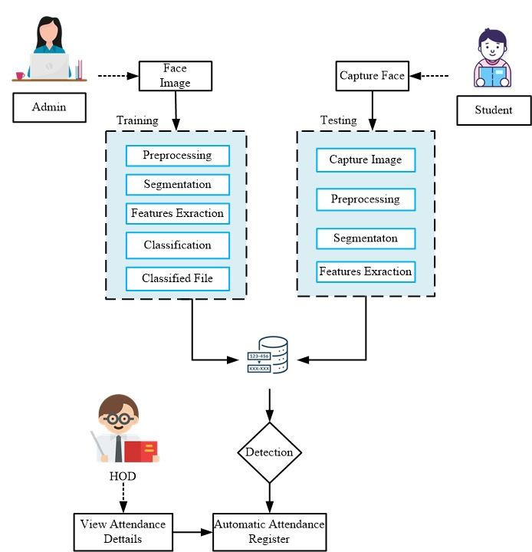

Fig. 3.1 System Architecture

**CHAPTER 4**

**SYSTEM SPECIFICATION**

**4.1 HARDWARE SPECIFICATION**

* + - Arduino Nano
    - RFID

**4.2 SOFTWARE SPECIFICATION**

* + - Server Side : Python 3.7.4(64-bit) or (32-bit)
    - Client Side : HTML, CSS, Bootstrap
    - IDE : Flask 1.1.1
    - Back end : MySQL 5.
    - Server : WampServer 2i
    - OS : Windows 10 64 –bit or Ubuntu 18.04 LTS “Bionic

Beaver”

* 1. **HARDWARE DESCRIPTION**

**Arduino Nano**

Arduino Nano is one [type of microcontroller](https://www.elprocus.com/arm7-based-lpc2148-microcontroller-pin-configuration/) board, and it is designed by Arduino.cc. It can be built with a microcontroller like  Atmega328. This microcontroller is also used in [Arduino](https://www.elprocus.com/arduino-sim-for-iot-based-devices-launched-by-arduino/) UNO. It is a small size board and also flexible with a wide variety of applications. Other [Arduino boards](https://www.elprocus.com/different-types-of-arduino-boards/) mainly include Arduino Mega, Arduino Pro Mini, Arduino UNO, Arduino YUN, Arduino Lilypad, Arduino Leonardo, and Arduino Due. And other development boards are AVR Development Board, PIC Development Board, [Raspberry Pi](https://www.elprocus.com/new-raspberry-pi-3-model-a-with-wi-fi-and-bluetooth/), Intel Edison, MSP430 Launchpad, and ESP32 board.

This board has many functions and features like an Arduino Duemilanove board. However, this Nano board is different in packaging. It doesn’t have any DC jack so that the power supply can be given using a small USB port otherwise straightly connected to the pins like VCC & GND. This board can be supplied with 6 to 20volts using a mini USB port on the board.

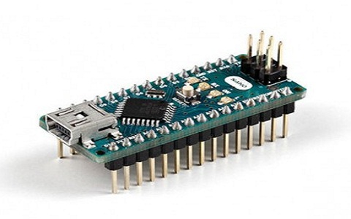

Fig 4.1 Arduino NANO

**RFID**

Radio-Frequency Identification (RFID) technology revolutionizes the way objects are identified, tracked, and managed by utilizing radio waves to transmit data between a reader and an RFID tag. Consisting of a tag or label containing a unique identifier and an RFID reader that captures and interprets the information, RFID systems offer a plethora of applications across various industries. The RFID tag, equipped with a microchip and antenna, can store data such as product details, inventory information, or security codes. When the RFID tag comes within range of an RFID reader's electromagnetic field, it powers up and transmits its stored data to the reader wirelessly. This process enables seamless and efficient identification and tracking of objects without the need for direct line-of-sight or manual scanning, thus streamlining inventory management, supply chain logistics, asset tracking, and access control processes. With its versatility, scalability, and cost-effectiveness, RFID technology has become indispensable in enhancing operational efficiency, improving visibility, and ensuring security in diverse industries worldwide.

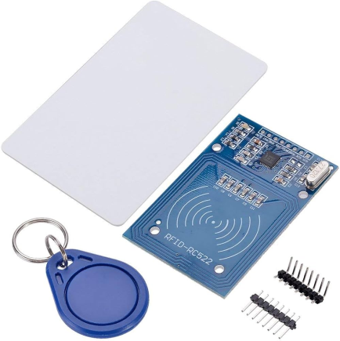

Fig.4.2 RFID Tag

RFID technology offers a myriad of benefits, including enhanced accuracy, real-time visibility, and automation of processes. By providing accurate and real-time data capture, RFID enables businesses to make informed decisions, optimize inventory levels, and reduce stockouts and overstock situations. In supply chain management, RFID facilitates end-to-end visibility, allowing companies to track the movement of goods from production to distribution, thereby improving traceability, reducing shrinkage, and enhancing security. Moreover, RFID systems can automate various processes, such as asset tracking and management, by enabling quick and accurate identification of assets and their status, minimizing manual interventions and human errors. Beyond inventory and logistics, RFID finds applications in retail, healthcare, transportation, and many other sectors, offering customized solutions to address specific industry challenges and requirements. With ongoing advancements in RFID technology, such as smaller and more cost-effective tags, improved read ranges, and enhanced data security features, the potential for innovation and adoption across industries continues to expand, promising even greater efficiency, visibility, and value in the years to come.

**4.4 SOFTWARE DESCRIPTION**

**4.4.1 Python**

Python is a general-purpose interpreted, interactive, object-oriented, and high-level programming language. It was created by Guido van Rossum during 1985- 1990. Like Perl, Python source code is also available

Fig. 4.3 Python Logo

under the GNU General Public License (GPL). This tutorial gives enough understanding on Python programming language.

Python is a high-level, interpreted, interactive and object-oriented scripting language. Python is designed to be highly readable. It uses English keywords frequently where as other languages use punctuation, and it has fewer syntactical constructions than other languages. Python is a MUST for students and working professionals to become a great Software Engineer specially when they are working in Web Development Domain.

Python is currently the most widely used multi-purpose, high-level programming language. Python allows programming in Object-Oriented and Procedural paradigms. Python programs generally are smaller than other programming languages like Java. Programmers have to type relatively less and indentation requirement of the language, makes them readable all the time. Python language is being used by almost all tech-giant companies like – Google, Amazon, Facebook, Instagram, Dropbox, Uber… etc. The biggest strength of Python is huge collection of standard libraries which can be used for the following:

* + - * Machine Learning
      * GUI Applications (like Kivy, Tkinter, PyQt etc.)
      * Web frameworks like Django (used by YouTube, Instagram, Dropbox)
      * Image processing (like OpenCV, Pillow)
      * Web scraping (like Scrapy, BeautifulSoup, Selenium)
      * Test frameworks
      * Multimedia
      * Scientific computing
      * Text processing and many more.

### Tensor Flow

Tensor Flow is an end-to-end open-source platform for machine learning. It has a comprehensive, flexible ecosystem of tools, libraries, and community resources that lets researchers push the state- of-the-art in ML, and gives developers the ability to easily build and deploy ML-powered applications.



Fig. 4.4 Tensor flow Logo

Tensor Flow provides a collection of workflows with intuitive, high-level APIs for both beginners and experts to create machine learning models in numerous languages. Developers have the option to deploy models on a number of platforms such as on servers, in the cloud devices, in browsers, and on many other JavaScript platforms. This enables developers to go from model building and training to deployment much more easily.

### Keras

Keras is a deep learning API written in Python, running on top of the machine learning platform TensorFlow. It was developed with a focus on enabling fast experimentation.

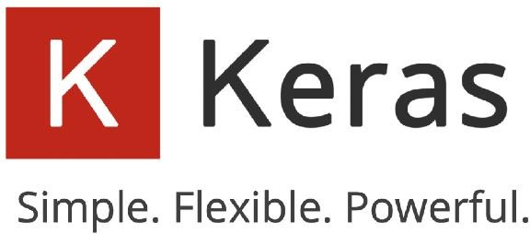  
Fig. 4.4 Keras Logo

* + - * Allows the same code to run on CPU or on GPU, seamlessly.
      * User-friendly API which makes it easy to quickly prototype deep learning models.
      * Built-in support for convolutional networks (for computer vision), recurrent networks (for sequence processing), and any combination of both.
      * Supports arbitrary network architectures: multi-input or multi-output models, layer sharing, model sharing, etc. This means that Keras is appropriate for building essentially any deep learning model, from a memory network to a neural Turing machine.

### Pandas

pandas is a fast, powerful, flexible and easy to use open source data analysis and manipulation tool, built on top of the Python programming language. pandas is a Python package that provides fast, flexible, and expressive data structures designed to make working with "relational" or "labeled" data both easy and intuitive. It aims to be the fundamental high-level building block for doing practical, real world data analysis in Python.



Fig. 4.5 Pandas Logo

### Pandas is mainly used for data analysis and associated manipulation of tabular data in Data frames. Pandas allows importing data from various file formats such as comma-separated values, JSON,Parquet, SQL database tables or queries, and Microsoft Excel. Pandas allows various data manipulation operations such as merging, reshaping, selecting, as well as data cleaning, and data wrangling features. The development of pandas introduced into Python many comparable features of working with Data frames that were established in the R programming language. The panda’s library is built upon another library NumPy, which is oriented to efficiently working with arrays instead of the features of working on Data frames

### NumPy

NumPy, which stands for Numerical Python, is a library consisting of multidimensional array objects and a collection of routines for processing those arrays. Using NumPy, mathematical and logical operations on arrays can be performed.



### Fig. 4.6 NumPy Logo

NumPy is a general-purpose array-processing package. It provides a high-performance multidimensional array object, and tools for working with these arrays.

### Matplotlib

Matplotlib is a comprehensive library for creating static, animated, and interactive visualizations in Python. Matplotlib makes easy things easy and hard things possible.



### Fig. 4.7 matplotlib Logo

Matplotlib is a plotting library for the Python programming language and its numerical mathematics extension NumPy. It provides an object-oriented API for embedding plots into applications using general-purpose GUI toolkits like Tkinter, wxPython, Qt, or GTK. lay a prominent role in monitoring and controlling external devices.

Python is used for railway track fault detection with image processing and CNN algorithms because it's like a versatile toolbox for solving complex problems. Imagine you have pictures of railway tracks, and you want to teach a computer to find problems like cracks or damage in these pictures.

Python helps us do this by using a smart technique called CNN, which is great at recognizing patterns in images. Python also has many helpful tools that make it easier to teach the computer and analyze the pictures.

So, it's like having a helpful assistant to spot track issues quickly and accurately, making train travel safer and more reliable.

**4.3.2 MySQL**

MySQL tutorial provides basic and advanced concepts of MySQL. Our MySQL tutorial is designed for beginners and professionals. MySQL is a relational database management system based on the Structured Query Language, which is the popular language for accessing and managing the records in the database. MySQL is open-source and free software under the GNU license. It is supported by Oracle Company.MySQL database that provides for how to manage database and to manipulate data with the help of various SQL queries.



### Fig. 4.8 MySQL Logo

These queries are: insert records, update records, delete records, select records, create tables, drop tables, etc. There are also given MySQL interview questions to help you better understand the MySQL database MySQL is currently the most popular database management system software used for managing the relational database. NumPy is a general-purpose array-processing package. It provides a high-performance multidimensional array object, and tools for working with these arrays.

**Wamp Server**

WampServer is a Windows web development environment. It allows you to create web applications

Fig. 4.9 Wamp Server Logo

WAMPServer is a reliable web development software program that lets you create web apps with MYSQL database and PHP Apache2. With an intuitive interface, the application features numerous functionalities and makes it the preferred choice of developers from around the world. The software is free to use and doesn’t require a payment or subscription. Bootstrap 4 Bootstrap is a free and open-source tool collection for creating responsive websites and web applications. It is the most popular HTML, CSS, and JavaScript framework for developing responsive, mobile-first websites.



### Fig. 4.10 Wampserver

It solves many problems which we had once, one of which is the cross-browser compatibility issue. Nowadays, the websites are perfect for all the browsers (IE, Firefox, and Chrome) and for all sizes of screens (Desktop, Tablets, Phablets, and Phones). All thanks to Bootstrap developers -Mark Otto and Jacob Thornton of Twitter, though it was later declared to be an opensource project.



### Fig. 4.11 Flask Logo

Flask is a web framework. This means flask provides you with tools, libraries and technologies that allow you to build a web application. This web application can be some web pages, a blog, a wiki or go as big as a web-based calendar application or a commercial website. Flask is often referred to as a micro framework. It aims to keep the core of an application simple yet extensible. Flask does not have built-in abstraction layer for database handling, nor does it have formed a validation support. Instead, Flask supports the extensions to add such functionality to the application. Although Flask is rather young compared to most Python frameworks, it holds a great promise and has already gained popularity among Python web developers. Let’s take a closer look into Flask, so-called “micro” framework for Python.

**CHAPTER 5**

**UML DIAGRAM**

**5.1 Use Case Diagram**

A use case diagram is a visual representation in the Unified Modeling Language (UML) that illustrates the interactions between various actors and a system in terms of specific use cases or functionalities. In a use case diagram, actors represent entities external to the system, while use cases depict the specific functionalities or actions that the system can perform. These diagrams provide a high-level overview of the system's intended behavior from the user's perspective.



Fig: 5.1 Use case Diagram

**5.2 Class Diagram**

A class diagram is a fundamental component of the Unified Modeling Language (UML) that visually represents the static structure of a system by illustrating the classes, attributes, relationships, and methods within that system. In a class diagram, classes are depicted as rectangles, with each class representing a blueprint for objects that share common attributes and behaviors. These attributes describe the characteristics of the objects, while methods represent the functions or operations they can perform.



Fig 5.2 Class Diagram

**5.3 Sequence Diagram**

A sequence diagram is a dynamic modeling tool in the Unified Modeling Language (UML) that visually represents the interactions and chronological order of messages exchanged among various objects or components within a system. In a sequence diagram, vertical lifelines represent different participants or objects, and horizontal arrows connecting these lifelines depict the flow of messages between them. The sequence of events is shown from top to bottom, illustrating the order in which messages are sent and received.

**5.4 Collaboration Diagram**

A collaboration diagram is a type of visual representation in the Unified Modeling Language (UML) that illustrates the interactions and relationships among objects or components within a system. Also known as a communication diagram, it emphasizes the flow of messages exchanged between objects to accomplish a specific task or scenario. In a collaboration diagram, objects are represented by rectangles, and lines with arrows indicate the messages or interactions between them.





Fig 5.4 Collaboration Diagram

**5.5 Activity Diagram**

An activity diagram is a graphical representation in the Unified Modeling Language (UML) that visualizes the dynamic aspects of a system by illustrating the flow of activities and actions within a particular process or use case. Activity diagrams are particularly effective in modeling workflows, business processes, and complex algorithms. In an activity diagram, activities are represented by rounded rectangles, and arrows depict the flow of control between these activities.



Fig: 5.5 Activity Diagram

**5.6 Component Diagram**

A component diagram in UML is a visual representation of a system's architecture, showcasing its key components (like modules or classes) and their relationships. Components encapsulate functionality, and connections between them depict how they interact. It provides a high-level overview of the system's structure, making it easy to understand how different parts collaborate to achieve the system's objectives.



Fig 5.6 Component Diagram

**CHAPTER 6**

**SYSTEM IMPLEMENTATION**

**6.1 PROJECT DESCRIPTION**

**6.1.1 Module List**

* Web Dashboard
* Face Recognition Module
* RFID Attendance Module
* Attendance Management System
* User Interface
* Scalability and Performance Optimization

**6.2 Module Description**

**1. Web Dashboard**

The web dashboard serves as the central management interface for the attendance management system, providing administrators and instructors with real-time access to attendance data, analytics, and controls. It offers intuitive visualization of attendance records, including attendance trends, student participation rates, and class summaries. Through the web dashboard, users can easily track attendance, generate reports, and manage class sessions efficiently.

**END USER**

Admin This module is handled by top management to create role wise user logins to staffs accessing College management ERP System. Admin can generate notificationsfor students and staff; send SMS, emails, reminders time to time. Here Admin can add/update/delete student/employee/courses, view course list/student list or many different modules.

Student Here Student can view profile, task, class schedules, exam report card, attendLive Class Session

Teaching Staff Faculty/AP/HOD can view profile, add task, exam reports, schedules.Here, they will be able to access the information of Students Profile, his detailed Feesaccount, his Term wise and Daily attendance and his appraisal report i.e., result statement along with the comparative graphical analysis – Term wise and Subject wise, which enables them to get evaluate the students’ performance in the Class and last but not the least his performance in various Co-curricular activities organized in the Institution.

**2.Face Recognition Module**

* 1. **Face Enrollment**

This module begins by registering a few frontal face of Bank Beneficiary templates. These templates then become the reference for evaluating and registering the templates for the other poses: tilting up/down, moving closer/further, and turning left/right.

# Face Image Acquisition

Cameras should be deployed in classroom to capture relevant video. Computer and camera are interfaced and here webcam is used.

# Frame Extraction

Frames are extracted from video input. The video must be divided into sequence of images which are further processed. The speed at which a video must be divided into images depends on the implementation of individuals. From we can say that, mostly 20-30 frames are taken per second which are sent to the next phases.

# Pre-processing

Face Image pre-processing are the steps taken to format images before they are used by model training and inference. The steps to be taken are:

* Read image
* RGB to Grey Scale conversion
* Resize image
* Remove noise (Denoise)

Smooth our image to remove unwanted noise. We do this using gaussian blur.

* Binarization

Image binarization is the process of taking a grayscale image and converting it to black-and-white, essentially reducing the information contained within the image from 256 shades of grey to 2: black and white, a binary image.

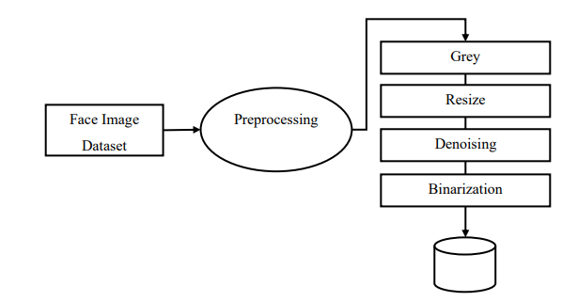

Fig 5.4 Pre Procesing

# Face Detection

Therefore, in this module, Region Proposal Network (RPN) generates RoIs by sliding windows on the feature map through anchors with different scales and different aspect ratios. Face detection and segmentation method based on improved RPN. RPN is used to generate RoIs, and RoI Align faithfully preserves the exact spatial locations. These are responsible for providing a predefined set of bounding boxes of different sizes and ratios that are going to be used for reference when first predicting object locations for the RPN.

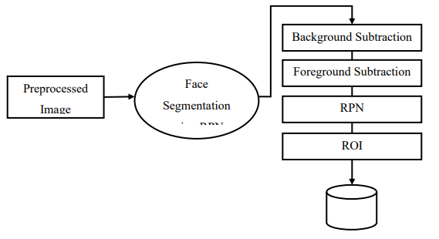

Fig 5.5 Fcae Detection

# Feature Extraction

After the face detection, face image is given as input to the feature extraction module to find the key features that will be used for classification. With each pose, the facial information including eyes, nose and mouth is automatically extracted and is then used to calculate the effects of the variation using its relation to the frontal face templates.

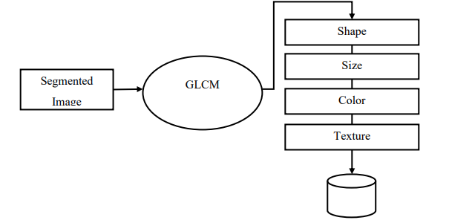

Fig 5.6 Feasture Extraction

# Face Classification

DCNN algorithms were created to automatically detect and reject improper face images during the enrolment process. This will ensure proper enrolment and therefore the best possible performance

# Face Identification

# The face identification module, powered by Convolutional Neural Network (CNN) algorithms, represents a sophisticated yet powerful component within the AI-based smart face attendance system. This module plays a pivotal role in enabling the system to accurately and efficiently recognize individual students based on their facial features. In this explanation, we'll delve into the intricacies of how this module operates, the training process involved, and its application within the context of attendance tracking in educational institutions.

# At its core, the face identification module is designed to mimic the human visual system's ability to identify and differentiate between faces. However, unlike humans, the module relies on complex mathematical computations and pattern recognition algorithms to perform this task. CNN algorithms, in particular, have emerged as a state-of-the-art approach for image recognition tasks due to their ability to learn hierarchical representations of features directly from raw pixel datas are detected.

# 3.RFID Attendance Module

# The RFID Attendance Module represents a breakthrough in attendance tracking technology, offering a seamless and efficient solution for organizations to monitor employee or student attendance. By integrating Radio Frequency Identification (RFID) technology into existing attendance systems, this module provides a convenient and reliable method for recording attendance without the need for manual data entry. This proposed explanation delves into the key features and benefits of the RFID Attendance Module, highlighting its potential to streamline attendance management processes and enhance organizational efficiency.

# Features and Benefits:

# The RFID Attendance Module offers a range of features designed to optimize attendance tracking and improve operational efficiency. Utilizing RFID tags and readers, the module allows employees or students to simply swipe or wave their RFID cards or tags to register their attendance, eliminating the need for manual sign-in procedures. This not only saves time and reduces administrative workload but also minimizes errors associated with manual data entry. Additionally, the module provides real-time attendance data, enabling organizations to monitor attendance trends, identify patterns, and generate reports effortlessly. With customizable settings and integration capabilities, the RFID Attendance Module seamlessly integrates into existing attendance systems, making it suitable for a wide range of applications and environments.

# Implementation and Integration

# Implementing the RFID Attendance Module involves integrating RFID readers and tags into existing infrastructure, along with deploying the necessary software and database management systems. Organizations can customize the module to suit their specific requirements, such as configuring attendance thresholds, defining access permissions, and generating automated alerts for late arrivals or absences. Integration with existing Human Resources Management Systems (HRMS) or Student Information Systems (SIS) ensures seamless data synchronization and compatibility with other organizational processes. Furthermore, the module can be easily scaled to accommodate varying organizational sizes and structures, making it suitable for small businesses, large enterprises, educational institutions, and more.

# 4. Attendance Management System

The attendance management system orchestrates the entire process of capturing, recording, and managing attendance data within virtual classrooms. It interfaces with the face recognition module to retrieve attendance information in real-time and stores it securely in a centralized database. Additionally, the system supports functionalities such as automated attendance marking, attendance history tracking, and notification alerts for irregularities or discrepancies.

Student attendance management enables easy tracking attendance information of students. Generate quick attendance reports with class wise analysis, monthly analysis and yearly analysis. There is also provision for HODs to take attendance with an web based or tablet. Staff attendance module maintain quick and accurate recording of staff attendance and automatically calculate the total leaves, pending leaves, working days. Various typesof leaves/absences/late comings can be marked for employees. By using this module, school management can easily record the regularity and punctuality of each employeeincluding late coming, early going and can determine salary payable efficiently.

* Subject/class wise attendance
* Attendance through web
* Attendance reports

**5. Scalability and Performance Optimization**

Scalability and performance optimization ensure the attendance management system can accommodate growing user demands and maintain high performance levels under varying workload conditions are accepted.

**CHAPTER 7**

**RESULT AND DISCUSSION**

The implementation of an AI-based smart face attendance system using Convolutional Neural Networks (CNN) represents a significant advancement in attendance management for educational institutions. By leveraging cutting-edge AI technology, this system offers several notable benefits, including improved accuracy, efficiency, and automation of attendance tracking processes. One of the key outcomes of the AI-based smart face attendance system is enhanced accuracy in attendance recording. Traditional methods of attendance taking, such as manual entry or RFID-based systems, are susceptible to errors, leading to inaccuracies in attendance records. However, with the utilization of CNN algorithms, the system achieves unparalleled precision in recognizing and verifying students' identities based on facial features.

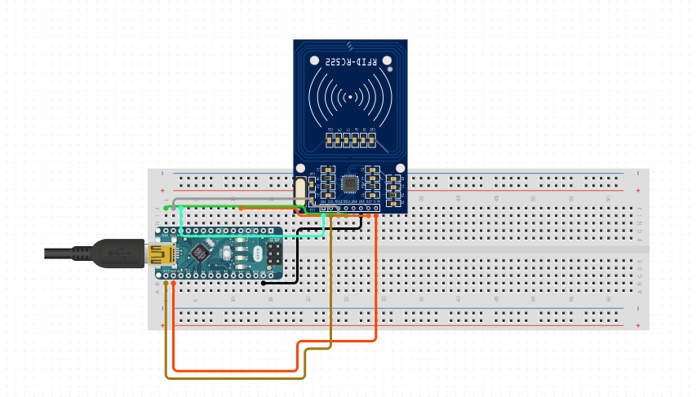

Fig 6.1 Arduino NANO and RFid reader circuit connection

This results in more reliable attendance data, reducing the likelihood of errors and ensuring greater accountability in tracking students' presence in classrooms. Moreover, the automation capabilities of the AI-based system streamline attendance management tasks, saving valuable time and resources for educational institutions. By automatically capturing and processing attendance data through facial recognition technology, the system eliminates the need for manual data entry or scanning procedures. This not only accelerates the attendance-taking process but also minimizes administrative burdens on faculty members and staff, allowing them to focus more on teaching and student engagement.

The seamless integration of the smart face attendance system with departmental workflows facilitates efficient communication and decision-making processes within colleges. The automatic transmission of attendance details to department heads (HODs) enables timely access to attendance records, empowering them to monitor student attendance trends, identify potential issues, and take proactive measures as needed. This real-time visibility into attendance data fosters greater transparency and accountability in academic management, leading to improved student outcomes and academic performance.

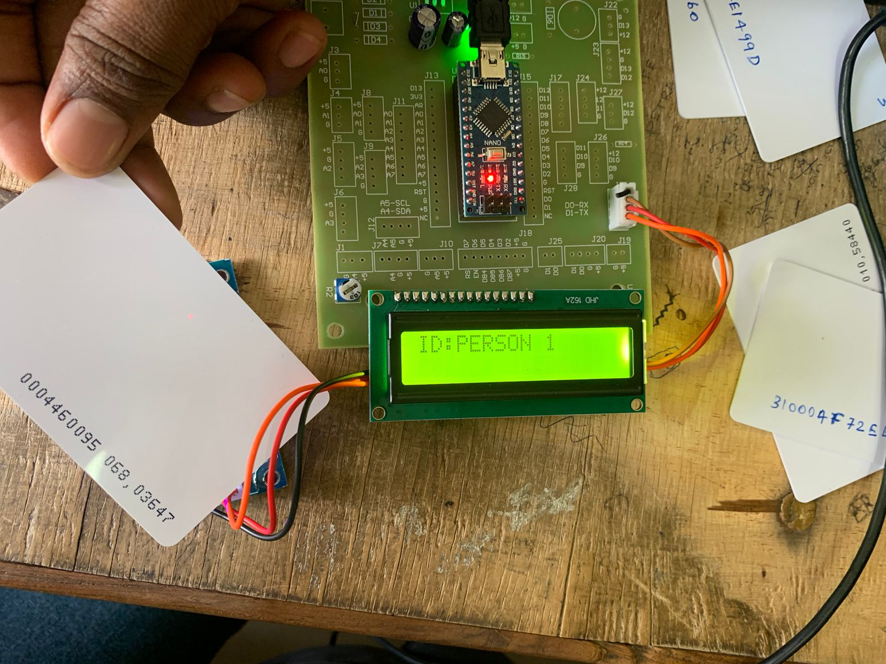

**Fig 7.1 initialize authentication**

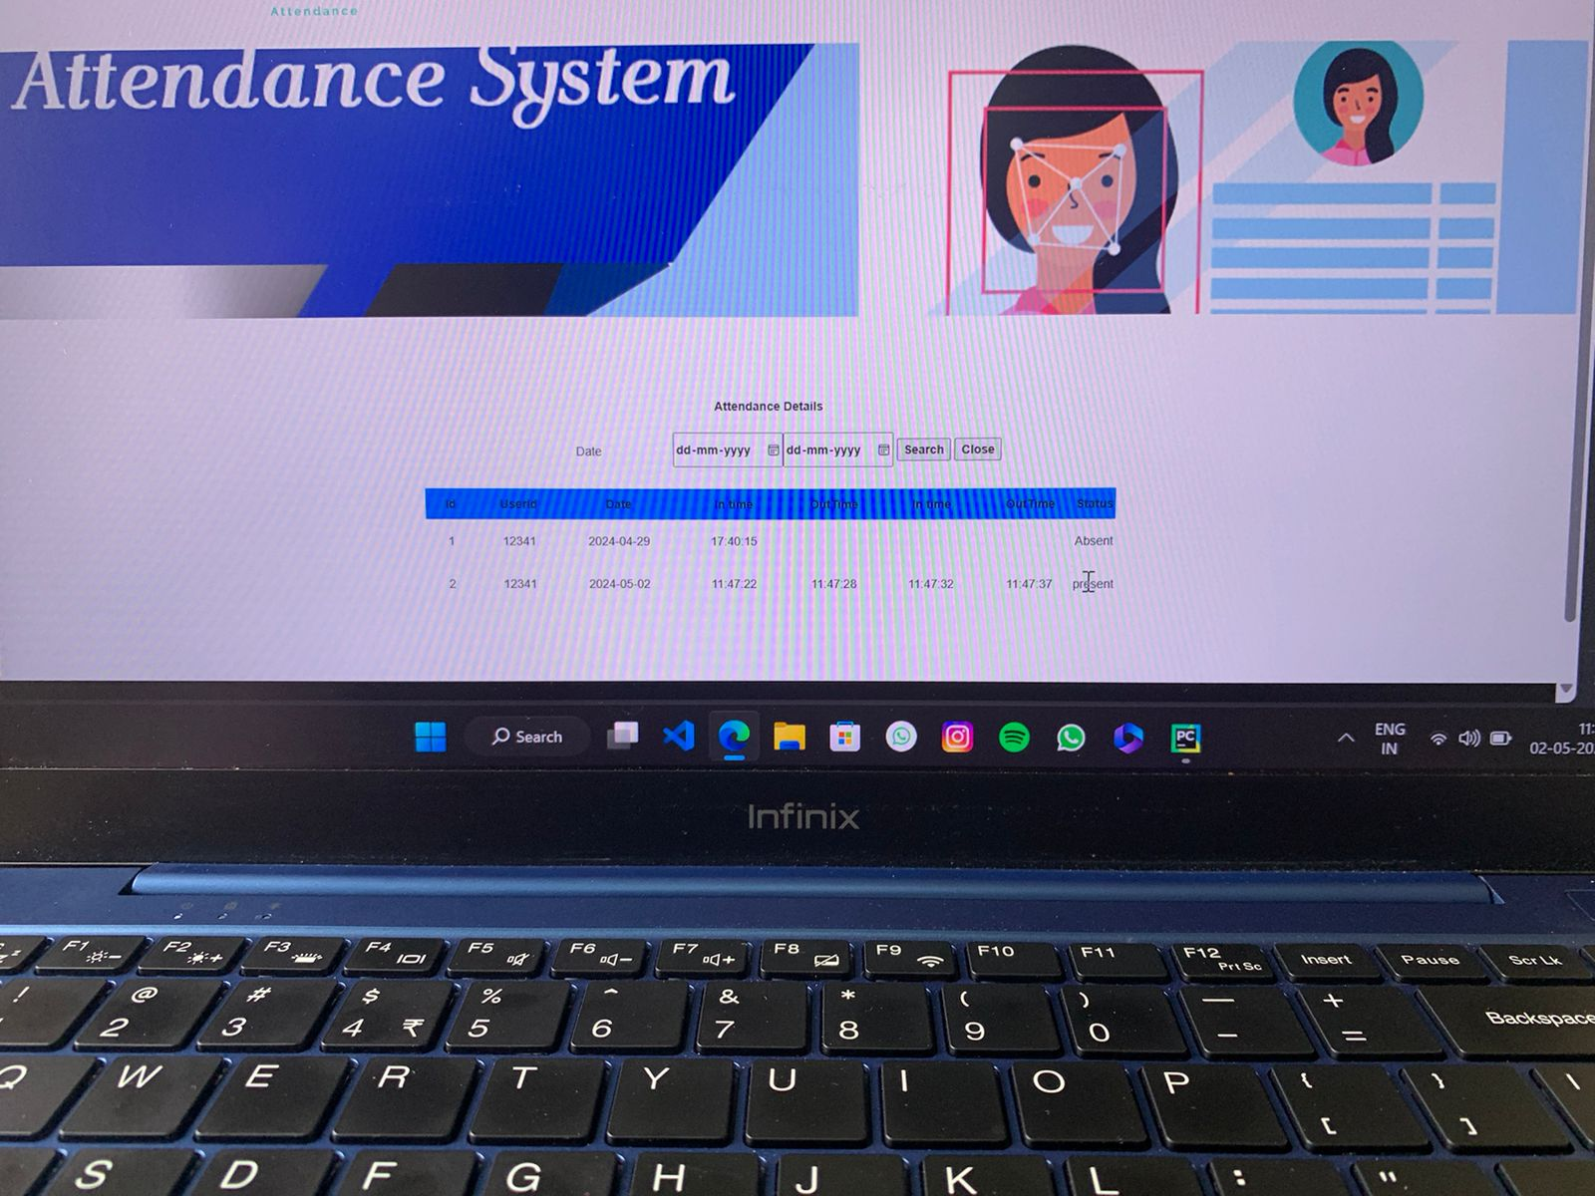

**Fig 7.2 Product in & out registrations**

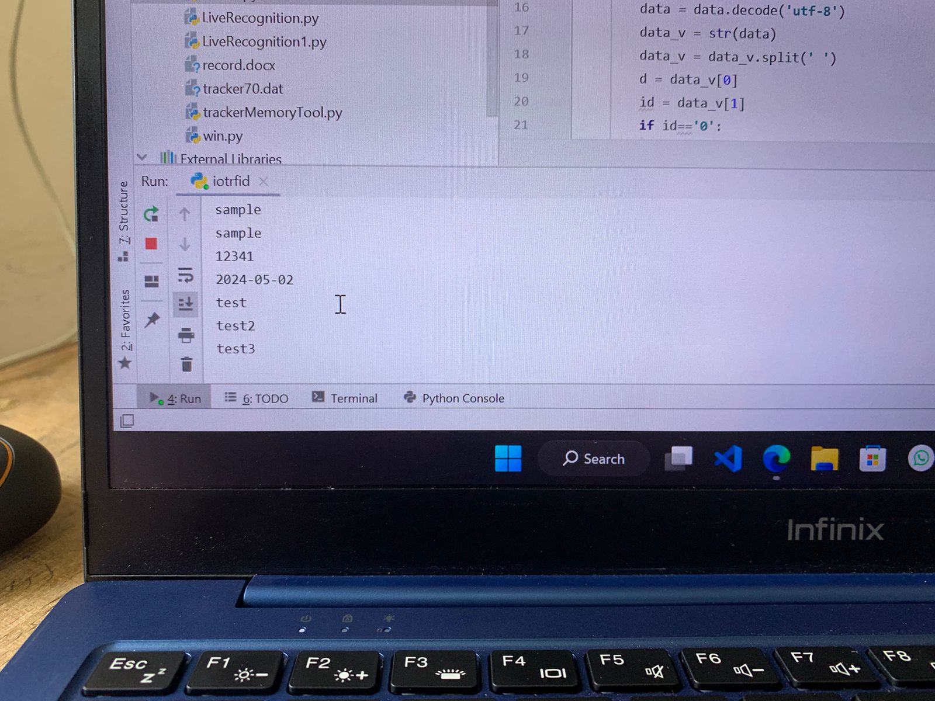

**Fig 7.3 Sample identification using RFid**

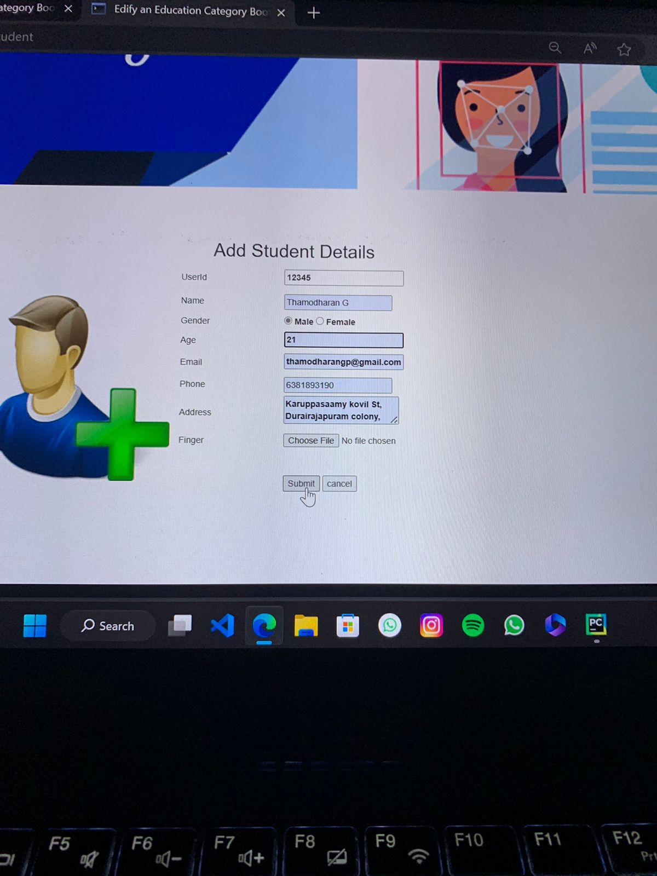

**Fig 7.4 Adding product details**

**CHAPTER 8**

**CONLCUSION AND FUTURE ENHAMCEMENT**

**8.1 Conclusion**

The implementation of the Smart Attendance System with AI marks a significant paradigm shift in the landscape of attendance tracking within educational institutions. This innovative system integrates RFID and facial recognition technologies, surpassing conventional methods to provide a seamless and efficient approach to recording student attendance. By combining the power of RFID tags and facial recognition capabilities, the system offers students the convenience of effortlessly registering their presence in classes. Gone are the days of manual attendance taking; students can now simply present their RFID cards or have their faces scanned, eliminating the tedious process of manual data entry. This not only saves time but also reduces the administrative burden on educators, allowing them to focus more on delivering quality education. Moreover, the integration of AI algorithms enhances the system's accuracy and reliability, ensuring precise attendance records. The Smart Attendance System with AI not only revolutionizes attendance tracking but also fosters a technologically advanced learning environment that prepares students for the digital age. Overall, this implementation represents a transformative leap forward in educational administration, streamlining processes and enhancing efficiency for both students and educators alike.

**8.2 Future Enhancement**

The implementation of the Smart Attendance System with AI represents a paradigm shift in the realm of attendance tracking within educational institutions. By harnessing the combined power of RFID and facial recognition technologies, this system has transcended traditional methods, offering a streamlined and efficient approach to recording student attendance. Through the integration of RFID tags and facial recognition capabilities, students now have the convenience of simply presenting their RFID cards or having their faces scanned to register their presence in classes, eliminating the need for manual attendance taking.

**APPENDIX**

**LIST OF FIGURES:**

|  |  |  |
| --- | --- | --- |
| **SL.NO** | **FIG NO.** | **FIG. NAME** |
| 1 | Fig1.1 | Face recoginition through product marking |
| 2 | Fig. 1.2 | Deployment of Languagres |
| 3 | Fig. 3.1 | DCNN |
| 4 | Fig. 3.2 | System Architecture |
| 5 | Fig. 4.1 | Arduino NANO |
| 6 | Fig 4.2 | RFid Tag |
| 7 | Fig. 4.4 | Tensor Flow |
| 8 | Fig 4.5 | Keras LOGO |
| 9 | Fig 4.6 | Pandas LOGO |
| 10 | Fig 4.7 | NumPy |
| 11 | Fig.4.8 | Matplotlib |
| 12 | Fig. 4.9 | MySQL |
| 13 | Fig 4.10 | Wamp Server Logo |
| 14 | Fig. 4.11 | Wamp Server |
| 15 | Fig 4.12 | Flask Logo |
| 16 | Fig. 5.1 | Use case diagram |
| 17 | Fig. 5.2 | Class Diagram |
| 18 | Fig 5.4 | Collabration Diagram |
| 19 | Fig 5.5 | Activity Diagram |
| 20 | Fig 5.6 | Component Diagram |
| 21 | Fig 6.1 | Pre-processing |
| 22 | Fig 6.2 | Face Detection |
| 23 | Fig 6.3 | Feature Extraction |
| 24 | Fig 6.4 | Arduino NANO and RFid Reader circuit connection |
| 25 | Fig 7.1 | Initialize authenticatin |
| 26 | Fig 7.2 | Product in &out registration |
| 27 | Fig 7.3 | Sample identification using Rfid |
| 28 | Fig 7.4 | Adding product details |

**SOURCE CODE:**

**//Header File**

**#include<LiquidCrystal.h>**

**LiquidCrystal lcd(7,6,5,4,3,2);**

**#include <SoftwareSerial.h>**

**SoftwareSerial myStream(10, 11);**

**//Buzzer**

**int buz = 13;**

**String sta;**

**int data1 = 0;**

**//RFID**

**int count = 0; // count = 0**

**char S[12]; // character array of size 12**

**boolean flag = 0; // flag =0**

**int ii,jj,kk = 0;**

**int incomingByte = 0;**

**void setup() {**

**// put your setup code here, to run once:**

**Serial.begin(9600);**

**myStream.begin(9600);**

**lcd.begin(16, 2);**

**lcd.setCursor(0,0);**

**lcd.print("SMART ATTENDANCE ");**

**lcd.setCursor(0,1);**

**lcd.print("MANAGEMENT SYSTEM ");**

**delay(1800);**

**digitalWrite(buz, HIGH);**

**delay(200);**

**lcd.clear();**

**digitalWrite(buz, LOW);**

**}**

**void loop() {**

**// put your main code here, to run repeatedly:**

**//Key**

**lcd.setCursor(0,0);**

**lcd.print("ID:");**

**lcd.print(sta);**

**lcd.print(" ");**

**myStream_rfid();**

**Serial.print("123");**

**Serial.print(" ");**

**Serial.print(data1);**

**Serial.println();**

**delay(1000);**

**}**

**//RFID**

**void myStream_rfid()**

**{**

**if(myStream.available())**

**{**

**count = 0;**

**while(myStream.available() && count <= 12) // Read 12 characters and store them in S array**

**{**

**S[count] = myStream.read();**

**count++;**

**delay(50);**

**}**

**//1- 3300440E3F46**

**if(S[0]=='3' && S[1]=='3' && S[2]=='0' && S[3]=='0' && S[4]=='4' && S[5]=='4' && S[6]=='0' && S[7]=='E' && S[8]=='3' && S[9]=='F' && S[10]=='4' && S[11]=='6')**

**{**

**delay(100);**

**//Serial.println("12341");**

**data1 = 12341;**

**sta = "PERSON 1";**

**}**

**else{**

**data1 = data1;**

**}**

**//2- 3100045D0860**

**if(S[0]=='3' && S[1]=='1' && S[2]=='0' && S[3]=='0' && S[4]=='0' && S[5]=='4' && S[6]=='5' && S[7]=='D' && S[8]=='0' && S[9]=='8' && S[10]=='6' && S[11]=='0')**

**{**

**delay(100);**

**//Serial.println("12342");**

**data1 = 12342;**

**sta = "PERSON 2";**

**}**

**else{**

**data1 = data1;**

**}**

**//3- 310004E1499D**

**if(S[0]=='3' && S[1]=='1' && S[2]=='0' && S[3]=='0' && S[4]=='0' && S[5]=='4' && S[6]=='E' && S[7]=='1' && S[8]=='4' && S[9]=='9' && S[10]=='9' && S[11]=='D')**

**{**

**delay(100);**

**//Serial.println("24321");**

**data1 = 12343;**

**sta = "PERSON 3";**

**}**

**else{**

**data1 = data1;**

**}**

**//4- 31000AE44897**

**if(S[0]=='3' && S[1]=='1' && S[2]=='0' && S[3]=='0' && S[4]=='0' && S[5]=='A' && S[6]=='E' && S[7]=='4' && S[8]=='4' && S[9]=='8' && S[10]=='9' && S[11]=='7')**

**{**

**delay(100);**

**//Serial.println("24321");**

**data1 = 12344;**

**sta = "PERSON 4";**

**}**

**else{**

**data1 = data1;**

**}**

**//5- 310004F72EEC**

**if(S[0]=='3' && S[1]=='1' && S[2]=='0' && S[3]=='0' && S[4]=='0' && S[5]=='4' && S[6]=='F' && S[7]=='7' && S[8]=='2' && S[9]=='E' && S[10]=='E' && S[11]=='C')**

**{**

**delay(100);**

**//Serial.println("24321");**

**data1 = 12345;**

**sta = "PERSON 5";**

**}**

**else{**

**data1 = data1;**

**}**

**}**

**else{**

**data1 = 00000;**

**}**

}

**REFERENCES**

1. L. Li, Q. Zhang, X. Wang, J. Zhang, T. Wang, T.-L. Gao, W. Duan, K. K.-F. Tsoi, and F.-Y. Wang, ``Characterizing the propagation of situational information in social media during COVID-19 epidemic: A case study on Weibo,'' IEEE Trans. Comput. Social Syst., vol. 7, no. 2, pp. 556-562, Apr. 2020.
2. P. Sahu, ``Closure of universities due to coronavirus disease 2019 (COVID-19): Impact on education and mental health of students and academic staff,'' Cureus, vol. 12, no. 4, p. 7541, Apr. 2020.
3. N. Iivari, S. Sharma, and L. Ventä-Olkkonen, ``Digital transformation of everyday life How COVID-19 pandemic transformed the basic education of the young generation and why information management research should care?'' Int. J. Inf. Manage., vol. 55, pp. 1-6, Dec. 2020.
4. J. B. Arbaugh, `` classroom versus physical classroom: An exploratory study of class discussion patterns and student learning in an asynchronous Internet-based MBA course,'' J. Manage. Educ., vol. 24, no. 2, pp. 213-233, Apr. 2000.
5. K. Aravindhan,S.K.B.Sangeetha,K.Periyakaruppan, K.P.Keerthana, V.SanjayGiridhar and V.Shamaladevi, "Design of Attendance Monitoring System using RFID " 7th International Conference on Advanced Computing and Communication Systems (ICACCS), 2021, pp. 1628-1631, doi: 10.1109/ICACCS51430.2021.9441704.
6. G Poorni, K Balaji, C DeepthiNivetha, A personalized e-learning recommender system using the concept of fuzzy tree matching in International journal of advanced research in computer engineering and technology, Volume 4, Issue 11 (2015).
7. K.Aravindhan, B.Evangeline Prasanna, “A Cluster Approach in VANET Using Collaborative Learning Automata - Based Routing” in Asian Journal of Information Technology, Volume 15, No.21 (2016) ISSN: 1993-5994 (Online) Page No: 4269-4275.
8. J. T. Wu, K. Leung, and G. M. Leung, ``Nowcasting and forecasting the potential domestic and international spread of the 2019-nCoV outbreak originating in Wuhan, China: A modeling study,'' Lancet, vol. 395, no. 10225, pp. 689-697, Feb. 2020.
9. T. Alamo, D. G. Reina, M. Mammarella, and A. Abella, ``Covid-19: Opendata resources for monitoring, modeling, and forecasting the epidemic,'' Electronics, vol. 9, no. 5, pp. 1-30, 2020.
10. C. Rapanta, L. Botturi, P. Goodyear, L. Guàrdia, and M. Koole, ``Online university teaching during and after the Covid-19 crisis: Refocusing teacher presence and learning activity,'' Postdigital Sci. Educ., vol. 2, no. 3, pp. 923-945, Oct. 2020.
11. Y. K. Dwivedi, D. L. Hughes, C. Coombs, I. Constantiou, Y. Duan, J. S. Edwards, B. Gupta, B. Lal, S. Misra, P. Prashant, R. Raman, N. P. Rana, S. K. Sharma, and N. Upadhyay, ``Impact of COVID-19 pandemic on information management research and practice: Transforming education, work and life,'' Int. J. Inf. Manage., vol. 55, Dec. 2020, Art. no. 102211.
12. M. H. Shehata, E. Abouzeid, N. F. Wasfy, A. Abdelaziz, R. L. Wells, and S. A. Ahmed, ``Medical education adaptations post COVID-19: An Egyptian reflection,'' J. Med. Educ. Curricular Develop., vol. 7, pp. 1-9, Aug. 2020.
13. R. H. Huang, D. J. Liu, A. Tlili, J. F. Yang, and H. H. Wang, Handbook on Facilitating Flexible Learning During Educational Disruption: The Chinese Experience in Maintaining Undisrupted Learning in COVID-19 Outbreak. Beijing, China: Smart Learning Institute of Beijing Normal Univ., 2020.
14. W. Bao, ``COVID-19 and online teaching in higher education: A case study of Peking University,'' Human Behav. Emerg. Technol., vol. 2, no. 2, pp. 113-115, Apr. 2020.
15. J. Crawford, K. Butler-Henderson, J. Rudolph, B. Malkawi, M. Glowatz, R. Burton, P. Magni, and S. Lam, ``COVID-19: 20 countries' higher education intra-period digital pedagogy responses,'' J. Appl. Learn. Teaching, vol. 3, no. 1, pp. 1-20, 2020.